TASK | Thread sealant used on hydraulic and pneumatic fittings
LOCATION OF USE | Workshop & Field Engineers |  | Assessment  No |  | 007
PRODUCT NAME | 545 Thread Sealant Pneumatic/Hydraulic Fittings |  |  |  | 007
DESCRIPTION OF SUBSTANCE | Adhesive |  |  |  | 007
MANUFACTURER | Henkel |  |  |  | 007
MANUFACTURERS CONTACT | Henkel Limited  Wood Lane End  Hemel Hempstead  HP2 4RQ  Great Britain  Phone: +44 1442278000  Emergency: 01442278497  ua-productsafety.uk@uk.henkel.com |  |  |  | 007
ASSESSOR | Martin Monaghan CMIOSH |  | Date |  | 23 07 24
TITLE | Health and Safety Consultant |  | Review by |  | 23 07 26
Personnel Performing Task  (Please list below)  Technicians/ Fitters/ Workshop Operatives |  | Time Spent  (Minutes/day)  As and when required, amounting to a few minutes per day | Training Given 
 |  |  | Yes

MSDS Revision Date | Hazard Statement
31/07/2015
  H315 Causes skin irritation.
  H317 May cause an allergic skin reaction.
  H319 Causes serious eye irritation.
  H335 May cause respiratory irritation.

Assessment to be conducted in Association with Hazard Data Sheets, a full current copy of which must be attached to this assessment.

Please denote the hazardous properties of the substances used in the task with a

NEW INTERNATIONAL GLOBALLY HARMONISED HAZARD SYMBOLS
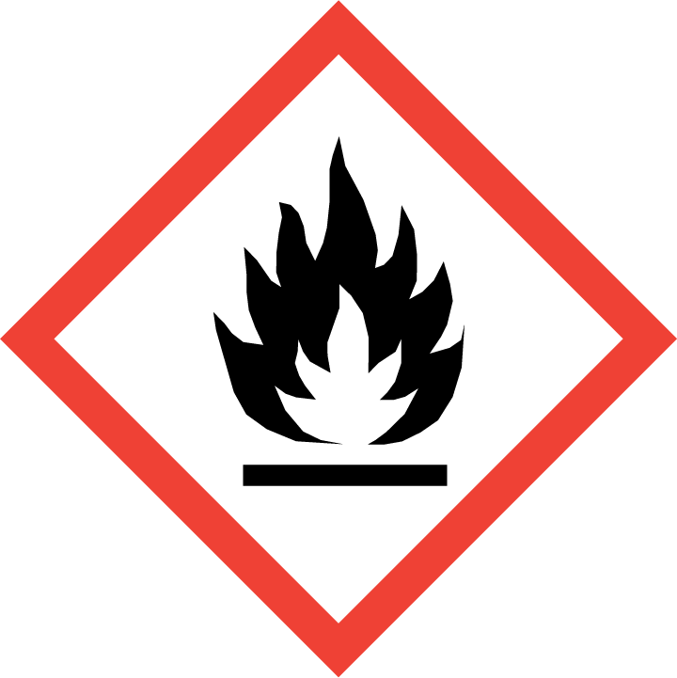 | 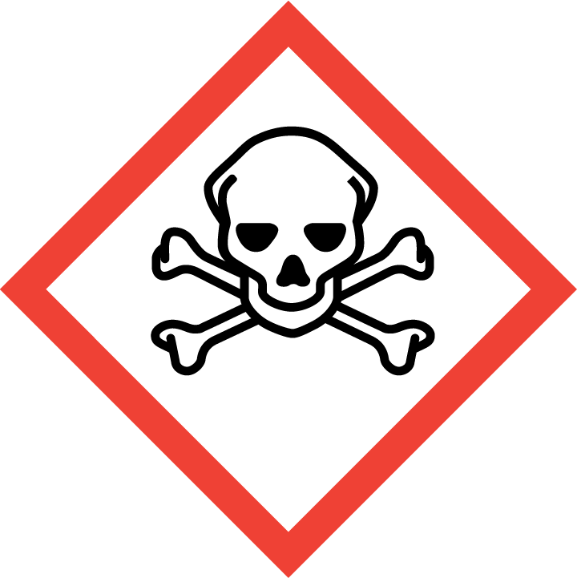 |  | 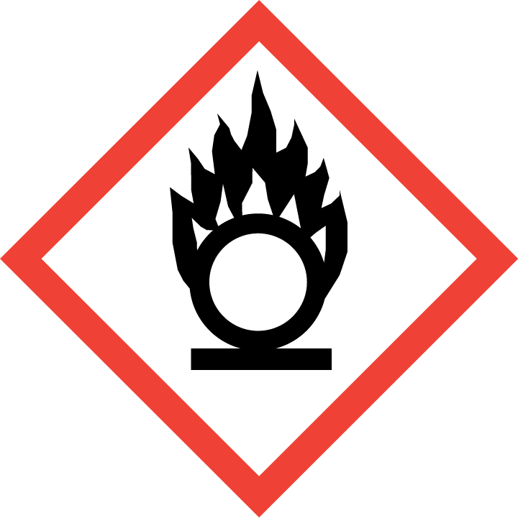 | 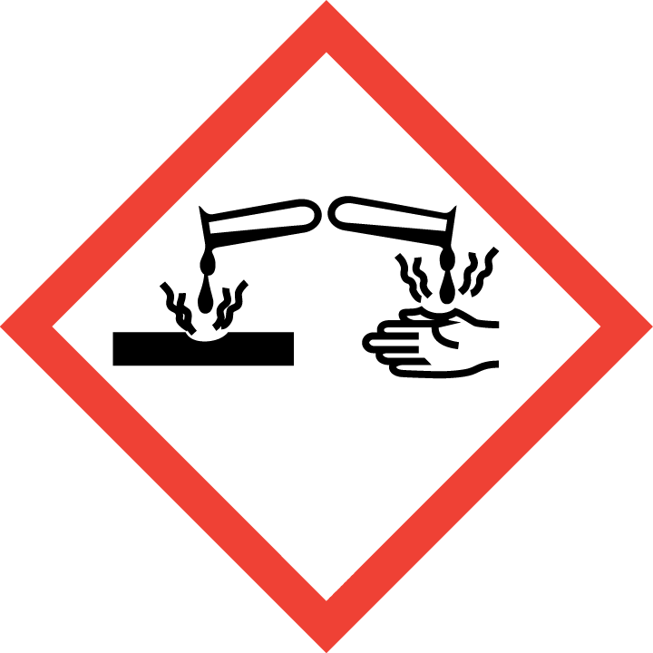 | 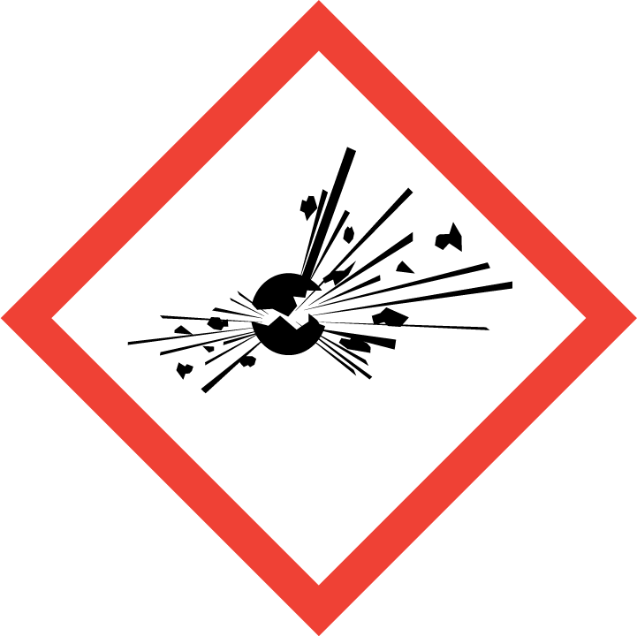 | 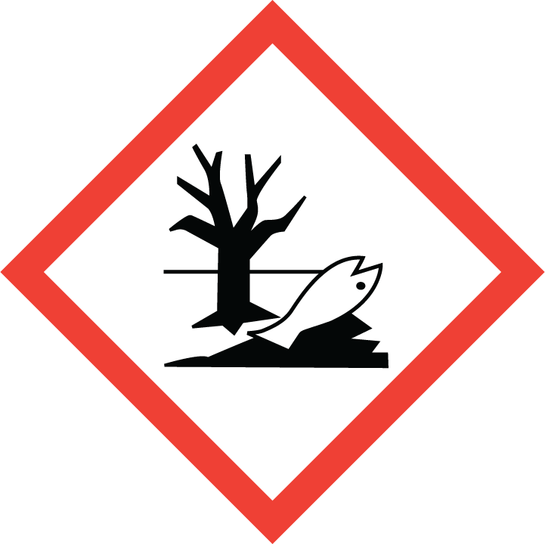 | 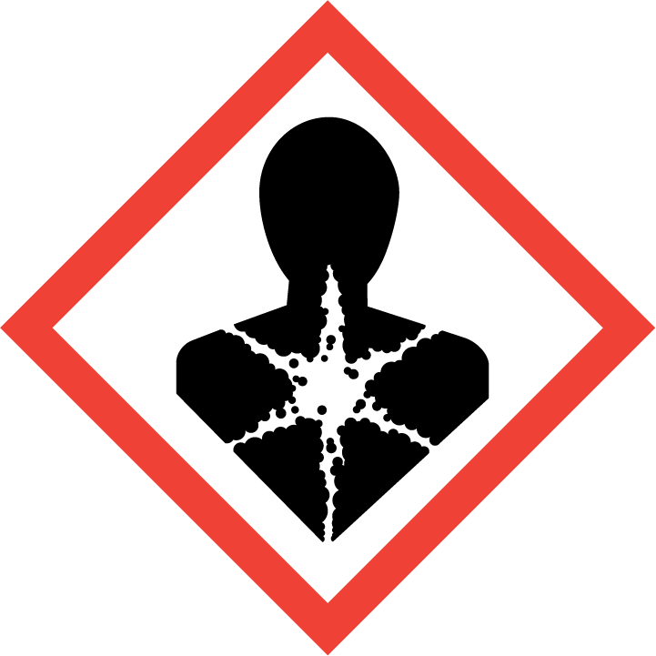
Flammable | Toxic | Irritant | Oxidising | Corrosive | Explosive | Harmful to the environment | Health Hazards i.e. respiratory sensitisation or carcinogenicity Limited evidence of carcinogenic effect

SMOKING, EATING AND DRINKING ARE PROHIBITED IN THE WORK AREAS.
Information, Instruction and Training must be provided to all users. Young Persons, New or Expectant Mothers and other vulnerable groups must not use or be exposed to this product.

WORKPLACE EXPOSURE LIMITS (WEL’s)
IMPORTANT!
Refer to Workplace Exposure Levels information provided in the Manufacturers Safety Data and revise control measures if exposure levels likely to be reached.

ROUTE OF EXPOSURE
Skin |  | Eyes |  | Inhalation
Ingestion |  | Cuts/abrasions |  | Systemic

PERSONS AT RISK
User of product |  | Co workers |  | Members of the public

ROUTE OF EXPOSURE |   FIRST AID MEASURES
Inhalation | Should not be a problem as product is of low volatility. However, if feeling  unwell remove patient to fresh air.
Ingestion | Rinse mouth, drink 1-2 glasses of water, do not induce vomiting, consult a  doctor.
Skin contact
  Rinse with running water and soap.
  Obtain medical attention if irritation persists.
Eye contact
  Rinse immediately with plenty of running water (for 10 minutes), seek medical attention from a specialist.
In all cases of doubt, or if symptoms persist seek medical attention. Never give anything by mouth to an unconscious person. If unconscious, place in recovery position and seek medical advice.

PERSONAL PROTECTIVE EQUIPMENT
 |  |  |  | 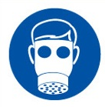 |  | 
YES | YES | YES/NO |  | YES/NO | YES | YES/NO
If splashing is likely wear EN166 safety glasses with side shields | Wear suitable protective clothing. |  |  | Must be worn if used in poorly ventilated area | Wear suitable protective gloves.

HANDLING | STORAGE | TRANSPORT | DISPOSAL
Use only in well ventilated areas. Do not breathe vapours. | Store in a cool, well-ventilated place.  Never allow product to get in contact with water during storage | Not hazardous | Product disposal:  Dispose of in accordance with local and national regulations.

REQUIRED CONTROL MEASURES
Avoid contact with skin and eyes, and inhalation of vapours/ spray or mist arising from the application of this preparation – Use PPE.
Only opened bottle should be kept at the bench.
When not in use, opened bottles should be kept in the flammables cupboards.
Surplus/ un-opened solvents must be kept in stores/ parts department.
Ensure adequate welfare and washing facilities available and provide users with barrier and restorative creams. Take good hygiene measures.
Ensure operatives are made aware of and understand the purpose of this assessment and SDS, plus any health implications of using the product.
Ensure COSHH assessments with accompanying SDS are made available for all employees and users and for inspection and emergency purpose.
Carry out personal exposure monitoring.
Good industrial hygiene practices should be observed. Wash hands before work breaks and after finishing work.

FIRE PRECAUTIONS
Extinguishing media: Carbon dioxide, foam, powder

Do not expose to direct heat, keep containers cool with water spray.

ACCIDENTAL RELEASE/SPILLAGE PROCEDURES
For small spills wipe up with paper towel and place in container for disposal.

For large spills absorb onto inert absorbent material and place in sealed container for disposal.

Ensure adequate ventilation.

Wear protective equipment, avoid contact with eyes and skin.

MONITORING REQUIREMENTS AND HEALTH SURVEILLANCE
Health surveillance is not in place for workers exposed to this product.

